# Deep Learning based Forecasting and Trading of Credit Derivatives Indices

Rajneesh Kumar Singh

*WorldQuant University*

*singhrajneesh@gmail.com*

# *Abstract*

In this paper we apply Deep Learning architecture to predict the spread of credit default swap (CDS) on the North America Investment Grade index (CDX.NA.IG). The implemented Long-Short Term Memory (LSTM) model is compared with a baseline model through the root mean squared error. Simulated trading is conducted in the study and the performance compared using Sharpe ratio and maximum loss metrics.

**Keywords:** CDS Spreads, LSTM

**1. Introduction**

In his debut non-fiction book titled “The Greatest Trade Ever: How One Man Bet against the Markets and Made $20 Billion”, American journalist Gregory Zuckerman narrates behind the scenes story of how John Paulson had pulled off the greatest trade in financial history. “By piling into complex "credit default swaps" against mortgages – in effect, insurance policies that would pay out if homeowners defaulted – his fund made an unthinkable $15bn (£9.8bn) in a year, $4bn of which he took home himself (Stewart, 2010)” and that dwarfed George Soros's billion-dollar currency trade in 1992. The 2015 movie “The Big Short” is based on the same trade.

Credit default swap (CDS) is a credit derivative instrument which is basically like an insurance on the default of the underlying reference entity. The reference entity could be a corporate or any sovereign. These are instruments which protects the buyer in case of default. In return the protection buyer pays a quarterly fee to the protection seller. Many such credit default swaps can be bundled together and form an index swap. For example CDX.NA.IG is one such portfolio of single-name credit default swaps on the 125 most liquid investment grade corporates in North America. European and other regional equivalents also trade actively. Further there are options and tranched products on these macro credit indices (Markit, 2021). For a more detailed understanding of the credit default swaps readers are referred to the Federal Reserve Board’s discussion paper on the same (Bomfim, 2022).

Credit derivative products gained immense notoriety and have largely been blamed for the Great Financial Crisis of 2008-2009. These markets had largely been unregulated before that and is still opaque to many market participants. In an IMF working paper (Elliott, 2009) the authors highlight how credit derivative markets can increase systemic risk due to the inter-connectedness of large financial institutions and how policy makers need to be aware of the “blind-spots” in this market.

Recently the CDS of Russian Federation came into focus as it launched a full-fledged war against Ukraine in early 2022. In Figure 1. we can see how the premium on the CDS sky-rocketed as the war progressed and there were fears that the Russian state would not honor the coupon payments on their outstanding bonds. Also notice the volatility around this CDS price.

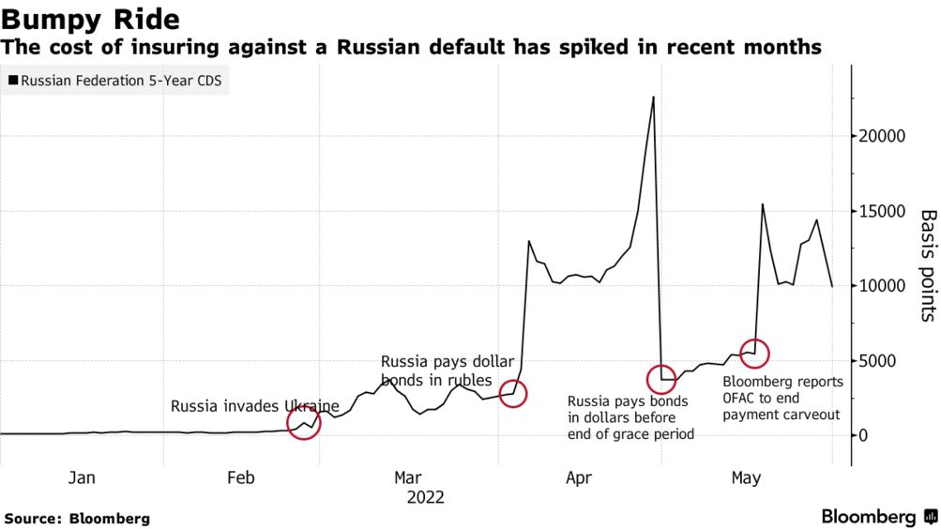

**Figure 1. Russia CDS during Ukraine War in 2022**

To implement a hedging and/or a trading strategy, the accurate forecasting of CDS spreads becomes important. This is useful not only for investors looking to gain from the price moves, it is important for risk managers looking to hedge counterpart risk and for policy makers framing a policy response to systemic risk after global markets.

We focus our forecasting task not at individual corporate or any country CDS. Our focus is going to be credit indices which are like barometer of overall credit risk of whole economy just as the VIX index represents volatility measure for macro equity index, SPX. While other asset classes like equity, bond and foreign exchange get lot of attention with regards to new forecasting techniques using machine learning and deep learning, work on credit derivative asset class looks minimal in comparison. We look to bridge this gap with our study.

**2. Related Work**

While a lot of studies has been done on the determinants of CDS spreads, the literature is sparse on price forecasting. (Avino, 2014) did an analysis of two linear forecasting models, ordinary least squares and an AR(1) model as well as a Markov regime-switching approach and found some evidence of statistical predictability. His instrument of choice was the iTraxx CDS index and the data covered the 2008 financial crisis. iTraxx index is a pool of CDS on 125 investment grade corporates in Europe. They found the Markov switching model underperforming the linear models under study.

With the advent of machine learning models researchers have begun to apply them to the credit derivative markets. Support Vector Machines were applied by (Gündüz, 2011) to single-name CDS prices and were found to outperform the Merton model. This study is extended by (Zhang, 2018) where they predict the returns rather than the CDS prices and also adds a few features.

In an IMF working paper by (Hu, 2019) ensemble machine learning methods were applied on firm level accounting-based, market-based and macroeconomic variables to generate CDS spreads which can be helpful for arriving at CDS spreads for companies who don’t have an active CDS market. The ensemble methods used were Bagging, Gradient Boosting and Random Forest.

Are CDS spreads predictable? And does efficient market hypothesis apply to the credit derivatives markets? With this dual goals (Vukovic, 2022) investigated the daily CDS spreads for 513 leading US companies over the time-period 2009-2020. The study splits the period as pre and post Covid-19 to check if there were changes in the market efficiency. The forecasting tools they used were Support Vector Machines, Group Method of Data Handling, Long Short-Term Memory and Markov switching auto regression. The results show the prediction results are not very different before and during Covid-19. But they did find that the market became less efficient during the pandemic. The GMDH and MSA models outperformed SVM and LSTM.

As we can see the latest machine learning and deep learning models for time series forecasting of credit default swaps spreads has been able to provide better results compared to traditional methods. This is consistent with the findings in other asset classes where researchers have been reporting superior results. This also means that efficient market hypothesis may not hold for CDS price movements and the moves may not be mere random walks. Fractal Market Hypothesis (FMH) could be an alternative for CDS prices especially during periods of market turbulence.

FMH studies have been conducted on various markets using a variety of methods to establish the fractal properties of the time series. Using the CDS spreads of Turkey, Russia, South Africa and Brazil, (Günay, 2016) examine the long-memory dependency in its volatility. Hurst Exponent Analysis was used by (Balkan, 2022) on the CDS spreads for 34 OECD countries between March 2003 and February 2020. Using rescaled range analysis with four different frequencies the researchers were able to show persistency in all CDS spreads and therefore upholding the FMH.

The pricing of CDS under Generalized Mixed Fractional Brownian motion has been considered by (He, 2014) and they provide a closed-form analytical expression for the CDS under risk-neutral assumption. The long memory in highly volatile time series of cryptocurrencies is examined using Hurst exponents of log returns in (Sheraz, 2022) as this nascent market has demonstrated sufficient divergence from normal distribution assumption.

**3. Methodology**

Our literature survey has provided evidence of long-term memory in CDS prices from two independent approaches that researchers have taken: fractal markets and using deep learning model like LSTM. This motivates us to combine the two approaches and see if better forecasting results can be achieved.

In this study we focus on Hurst Exponent Analysis for short term trading of CDX.NA.IG. We will use Hurst Exponent to classify our time series as trending or mean-reverting. Mean-reversion occurs over shorter timeframes and since our focus is short term trading we expect to do more work identifying the mean reversion signals. We might use other signals and indicators like moving average or RSI indicators to enter into a trade and test alpha generating trading strategies. We also explore machine learning and deep learning models for comparison with our Hurst model. To our knowledge there are no study using Hurst Exponent and machine learning/deep learning at the same time.

**3.1. Data**

We hone in on 5-year CDS spreads on investment grade bond issuances from North American entities. In particular, we focus on a particular credit index – CDX.NA.IG published and managed by Markit. The index consists of investment grade CDSs from 125 entities in the region. We acquired CDX.NA.IG pricing data (expressed in basis point) from the Bloomberg terminal (courtesy of GSB library). Since the index adjusts its constituent list every 6 months (technical term “roll”), we will use the roll-adjusted mid daily closing price for our purpose. Due to data availability, we were unable to collect CDX.NA.IG pricing data before September 11, 2011. As a result, our dataset spans from September 11, 2011 to October 30, 2020 with a total of 2282 data points (discussed in next section). We reserve about 15% of the dataset (or 343 data points) for testing

**3.2. Models and Training**

We apply RNN-based architectures to the prediction task and investigate model performance. As a benchmark, we include classic models inspired by research. Mean Squared Error (MSE) is the primary performance metric. We also report Mean Absolute Error (MAE) as well as Mean Absolute Percentage Error (MAPE) as additional metrics. Calculations of these metrics are provided in Appendices section.

We use MSE as loss function because we strive to minimize the difference between predicted return and true return. In training time, we pre-process original input and obtain windowed input. That is, we pair up examples from l previous steps with the current step CDS spread log return (l is the look-back window size). We then shuffle the pairs and pick B pairs to form a training batch (B is the batch size). An entire epoch is concluded when all pairs have been fed into the model. Adam is the choice of optimizer. As we are exploring different learning rates in cross validation, we keep β1 = 0.9, β2 = 0.999, and decay rate = 0 fixed. In testing time, we also first generate windowed inputs, but they go through the trained model sequentially. In all cases, we keep batch size to be B = 64.

Use this section to outline how you conducted your research study. This includes the specific techniques and tools you used to collect and analyze your data, any constraints you encountered as well as how you were able (or unable) to manage these constraints.

**4. Results**

The Results section is where you will present your data. Use figures, tables, and graphs to clearly represent information in a logical order. Only include the data that is most relevant to your report in this section. If you want to include additional or non-essential data for context or clarity, you can add an appendix at the end of your report.

**5. Discussion**

In this section, you will analyze the data you presented in your results and interpret this data in light of your research question or hypothesis. Use this section to explain what your results mean and how they relate to, or contribute to, existing research and knowledge in the field.

**6. Conclusion**

The conclusion is where you will provide a concise summary of your results and findings. It is very important that no new ideas or data are introduced in your conclusion. Make sure you include all the key information that was presented in the results and discussion.

# Appendix

**A. GitHub Repository**

An online repository for the current project is publicly available at the below GitHub address. The plan is to provide all the files and working codes to the online repository.

<https://github.com/rks972633/MScFE_Capstone>

**B. Pseudocode**

Below algorithm for calculation of Hurst Exponent is motivated from (Sheraz, 2022).

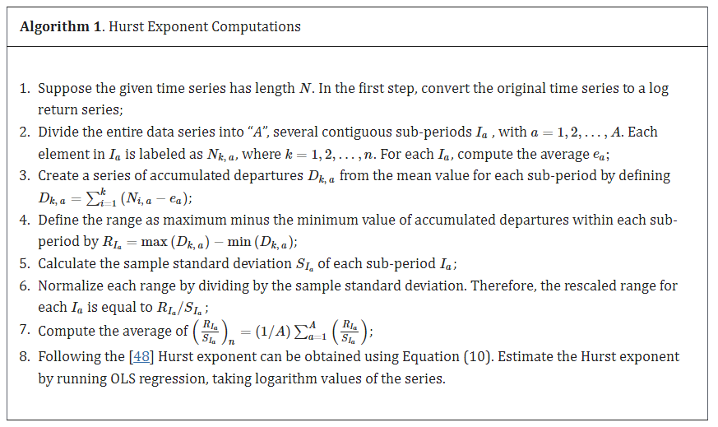

# Acknowledgments

I would like to thank Dr. Tiberiu Stoica at WorldQuant University for the guidance provided throughout the conduct of this study.

**References**

1. D. Avino and O. Nneji, “Are CDS spreads predictable? An analysis of linear and non-linear forecasting models”, International Review of Financial Analysis, vol. 34, **(2014)**, pp. 262-274.
2. E. Balkan and U. Uyar, “The Fractal Structure of CDS Spreads: Evidence from the OECD Countries”, Romanian Journal of Economic Forecasting, vol. 25.1, **(2022)**, pp. 106.
3. Bomfim, A. N. **(2022)**. Credit Default Swaps. Finance and Economics Discussion Series 2022-23. Retrieved from https://doi.org/10.17016/FEDS.2022.023.
4. Elliott, M. J. **(2009)**. Credit derivatives: systemic risks and policy options? International Monetary Fund.
5. Günay, S. a. **(2016)**. Long-memory in volatilities of cds spreads: evidences from the emerging markets. ournal for Economic Forecasting 1, 122-137.
6. Gündüz, Y. a.-H. **(2011)**. Predicting credit default swap prices with financial and pure data-driven approaches. Quantitative Finance 11.12, 1709-1727.
7. Gupta, R. G. **(2020)**. Retrieved from https://streetfins.com/analyzing-bill-ackmans-2-6-billion-cds-trade/.
8. He, X. a. **(2014)**. The pricing of credit default swaps under a generalized mixed fractional Brownian motion. Physica A: Statistical Mechanics and its Applications 404, 26-33.
9. Hu, N. J.-C. **(2019)**. Completing the Market: Generating Shadow CDS Spreads by Machine Learning. International Monetary Fund.
10. Markit, I. **(2021)**. Retrieved from https://cdn.ihsmarkit.com/www/pdf/1221/CDS-Indices-Primer---2021.pdf.
11. Sheraz, M. S. **(2022)**. Volatility Dynamics of Non-Linear Volatile Time Series and Analysis of Information Flow: Evidence from Cryptocurrency Data. Entropy 24.10, 1410.
12. Stewart, H. **(2010, March 07)**. Retrieved from https://www.theguardian.com/books/2010/mar/07/the-greatest-trade-ever-by-gregory-zuckerman-review-heather-stewart.
13. Vukovic, D. B. **(2022)**. Are CDS spreads predictable during the Covid-19 pandemic? Forecasting based on SVM, GMDH, LSTM and Markov switching autoregression. Expert systems with applications .
14. Zhang, T. Y. **(2018)**. Predicting Credit Default Swap (CDS) Returns with Machine Learning. Available at SSRN 3152143.

**Authors**



**Rajneesh Kumar Singh,** is a current student at WorldQuant University pursuing his Master of Science in Financial Engineering. He has been a financial markets professional for over 15 years and has mostly worked in the field of Credit Derivatives in various roles. Currently he works as a Credit Quantitative Research in a London based credit hedge fund.